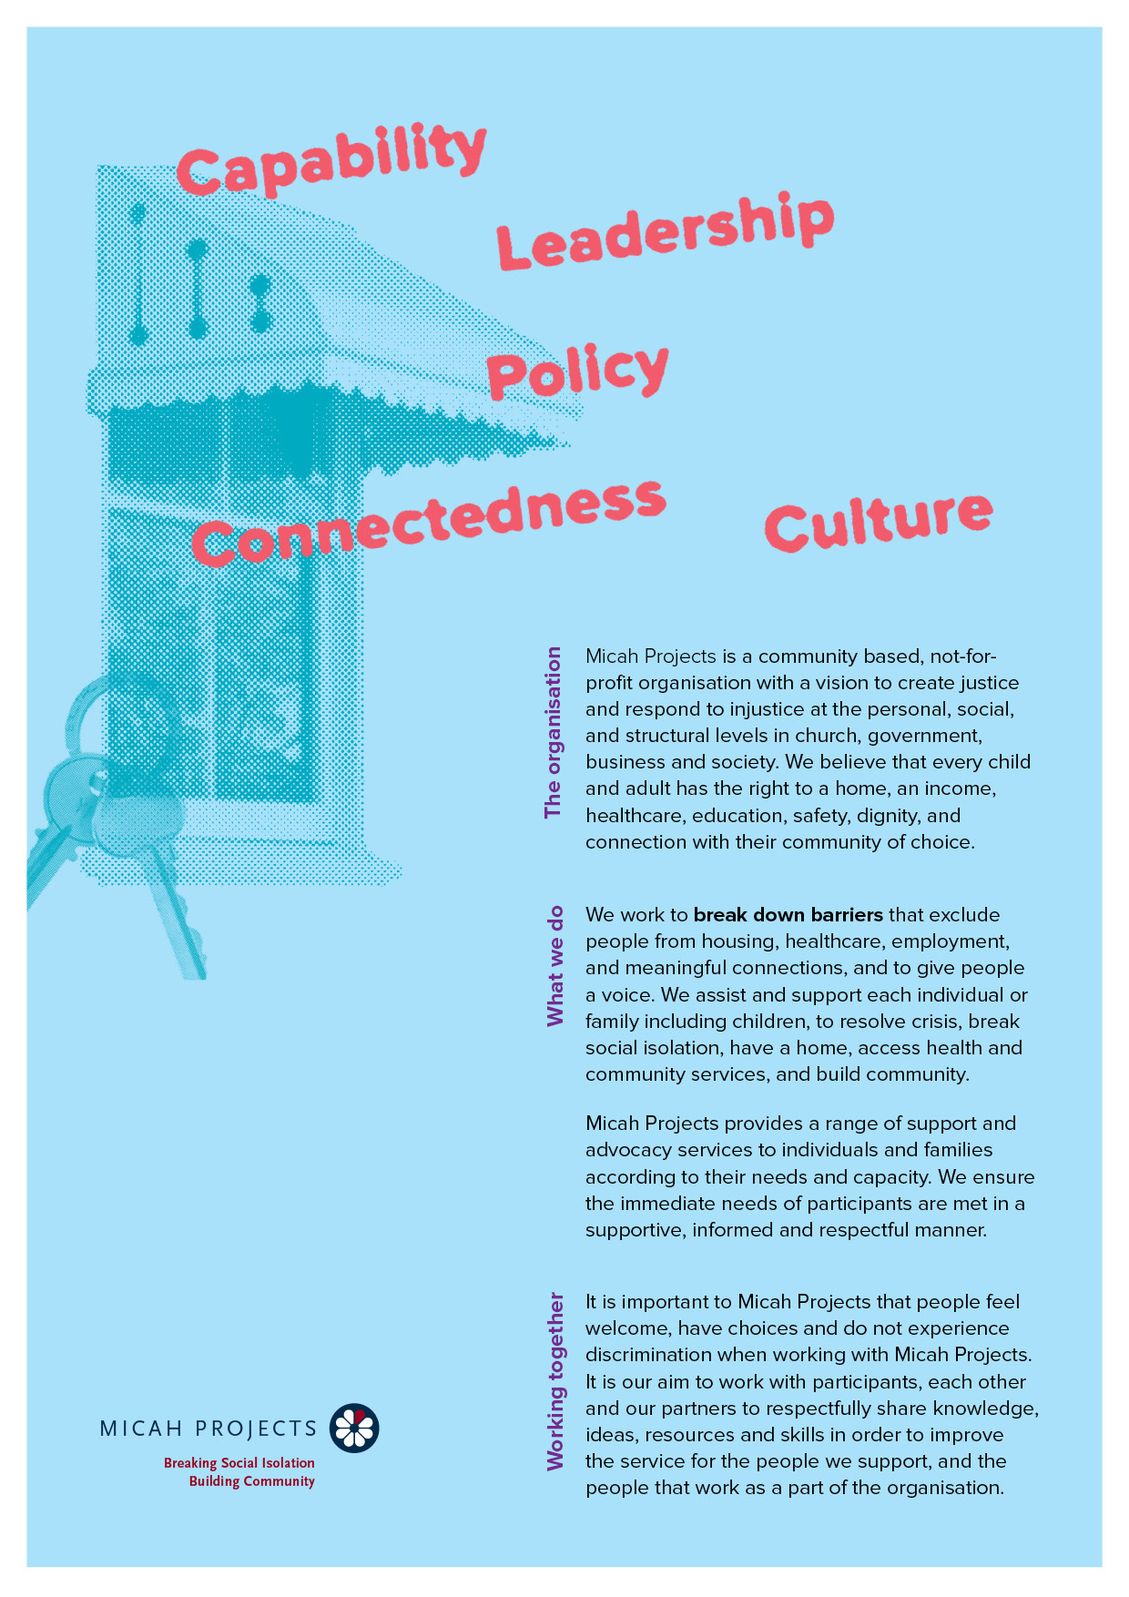
Art Group Assistant
Volunteer

Equal Opportunity  Micah Projects is an equal opportunity employer and promotes access to positions to individuals from a diverse range of social and cultural groups. We acknowledge the First Peoples of Australia as the traditional owners of this land and support their right to self-determination and cultural expression. We recognise that Brisbane is a diverse community and acknowledge the needs of individuals, families and communities relating to age, gender, disability, sexuality and economic status. | Child Safe Organisation  Children and young people are entitled to live in a caring and nurturing environment and to be protected from harm and exploitation. Micah Projects is a child-safe and child-friendly organisation that prioritises the safety and wellbeing of children and young people. We actively provide guidance for management, staff and others in identifying and responding to concerns about the abuse or neglect of a child or young person in contact with the organisation.
Quality statements  Micah Projects is committed to adhering to well defined, effective procedures that are designed to ensure the quality of our services and activities. We expect staff to understand the relevance and importance of their activities and how they contribute to achieving the quality objectives, and to proactively work and operate within the organisation’s quality system. | WHS Statement  Everyone has a right to feel safe at work, and Micah Projects is committed to minimising the risk to any staff member, student, volunteer, contractor, consultant and Board member within the organisation. We work collectively to comply with the Work Health and Safety Act 2015.


Position Overview

Position Title | Team
  Art Group Assistant
  Lotus Place
Reports to | Line Manages
  Katie McGuire
  Mel Smith
Employment Status | Hours of Work
  Volunteer
  Thursday (weekly)
  12.30pm – 3.30pm
Based at
Stones Corner 4120

Lotus Place (South Queensland) is a dedicated support and resource centre for people who grew up in institutional or out-of-home care settings and experienced abuse, neglect, or trauma. As part of the Historical Abuse Network’s advocacy and ongoing Government commitments, Lotus Place provides a welcoming environment offering connection, support, and opportunities for healing, learning, and community.

Position Description

As an Craft Assistant volunteer, you will….
The Volunteer Art & Craft Assistant plays an important role in supporting the delivery of Thursday creative sessions. Working alongside the Art Facilitator, you will help prepare materials, welcome participants, offer gentle creative assistance, and contribute to a relaxed, inclusive studio environment.
You will assist participants to engage in activities at their own pace, help maintain an organised and safe studio space, and support the facilitator during set-up, pack-down, and general studio needs. This role is perfect for someone who values creativity, community connection, and supporting others in a warm and respectful environment.
Responsibilities  - Assist with preparing, delivering, and packing down weekly Art and Craft sessions.  - Welcome participants and offer supportive, respectful engagement throughout sessions.  - Provide simple art or craft assistance under the direction of the facilitator (within your own skills and comfort level).  - Encourage creativity, confidence, and a sense of achievement among group members.  - Help maintain a calm, inclusive, trauma-informed group culture.  - Keep the studio tidy and organised; assist with basic materials tracking.  - Support occasional additional studio tasks (e.g., reorganisation, open studio set-up) as needed. | Interactions and Relationships
  - Participants
  - Social Inclusion Workers
  - Volunteer Coordinator
  - Members of the Community

Criteria and Conditions

Driver’s License: Preferred but Not Essential | Travel: Optional
Criminal History Screening: Blue Card (mandatory) | Assets: N/A

Essential
- Warm, friendly, and respectful communication style.
- Ability to work as part of a team and follow guidance.
- Reliability, consistency, and a patient, supportive approach.
- Comfortable engaging with people from diverse backgrounds and lived experiences.
- Ability to work with minimal supervision when required.
- Genuine interest in art, craft, creativity, and community connection.
- Respect for boundaries, confidentiality, and the values of Micah Projects.
- Ability to provide a non-relative character referee.
- Blue Card (Working with Children Check) — mandatory; can be applied for at commencement.

Desirable Skills
- Experience in one or more art or craft mediums (painting, drawing, collage, ceramics, textiles, etc.).
- Experience supporting others in community, group, or wellbeing settings.
- Basic organisational skills (e.g., helping with set-up or simple materials lists).
- Awareness of trauma-informed or mental health support principles (training can be provided).

What You’ll Gain
- The chance to be part of a warm, welcoming, purpose-driven community.
- Hands-on experience supporting a creative, wellbeing-focused program.
- Mentorship and learning opportunities from experienced arts and community practitioners.
- Enhanced communication, facilitation, and creative support skills.
- A professional reference to support future employment, study, or creative pathways.

General Conditions
» All volunteers are to exhibit the values of Micah Projects, as outlined in the Code of Conduct.
» All volunteers must utilise Micah Projects systems to facilitate the quality of the organisation’s work and services.
» Appointment to this position will be subject to a criminal history check, as outlined in the organisational Criminal History Screening Policy.
» All volunteers will comply with Workplace Health and Safety legislation as outlined in organisational policy and procedures.

Volunteer Expression of Interest

