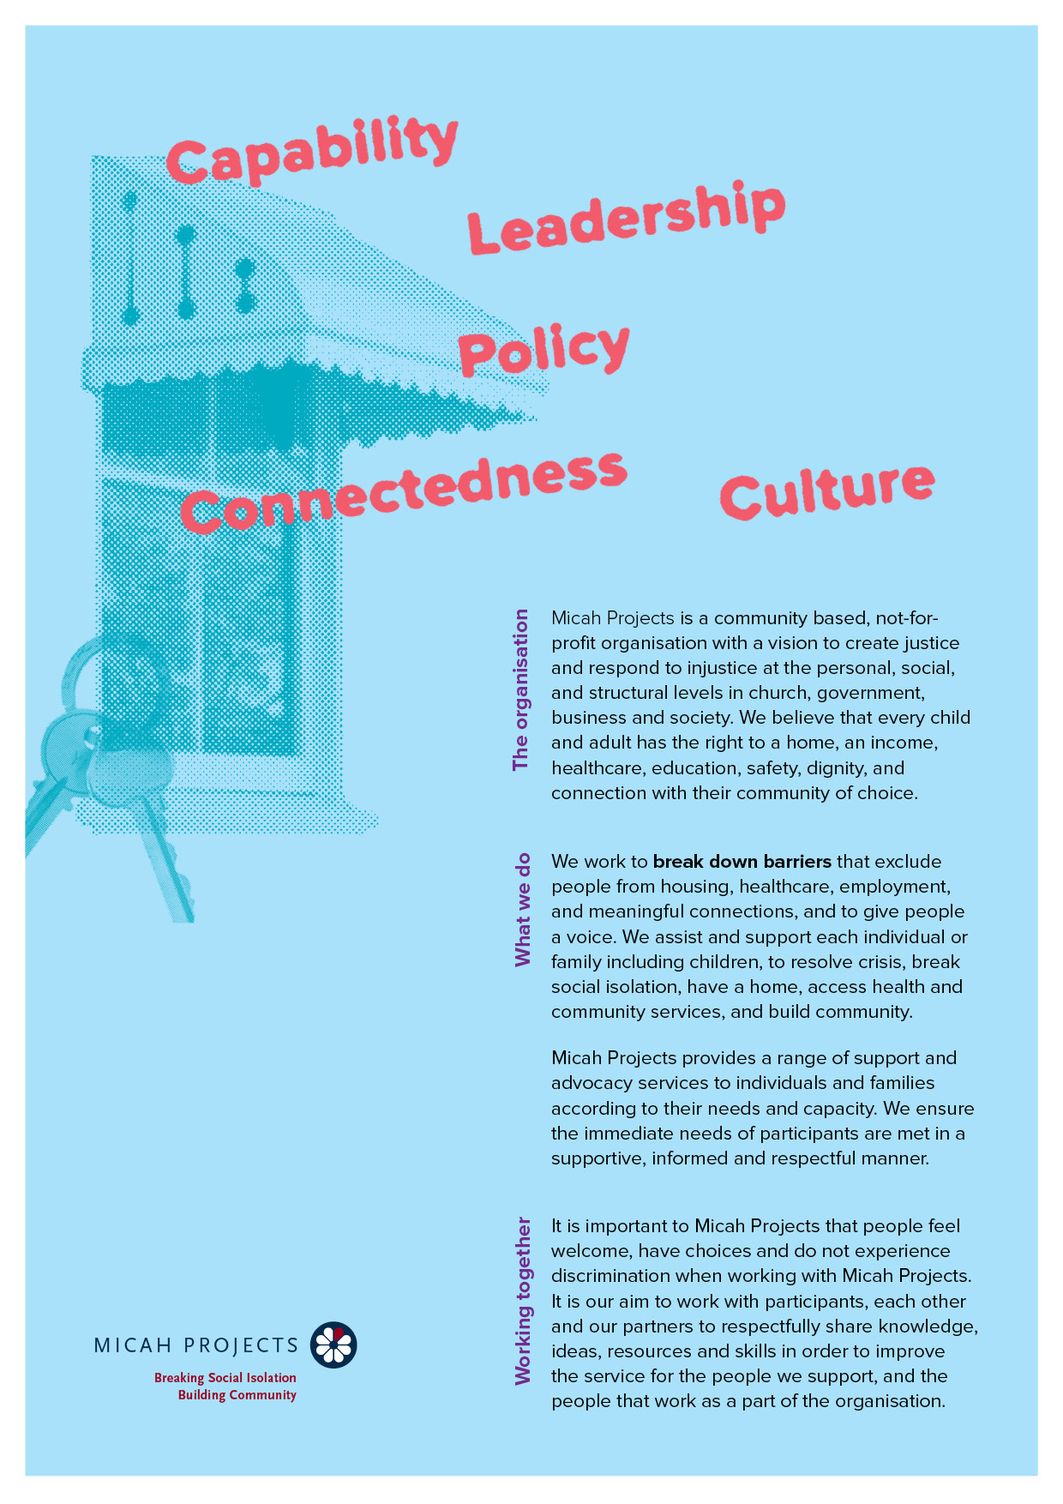
Community Meal
Volunteer at
Supportive Housing – Hope Street

Volunteer

Equal Opportunity  Micah Projects is an equal opportunity employer and promotes access to positions to individuals from a diverse range of social and cultural groups. We acknowledge the First Peoples of Australia as the traditional owners of this land and support their right to self-determination and cultural expression. We recognise that Brisbane is a diverse community and acknowledge the needs of individuals, families and communities relating to age, gender, disability, sexuality and economic status. | Child Safe Organisation  Children and young people are entitled to live in a caring and nurturing environment and to be protected from harm and exploitation. Micah Projects is a child-safe and child-friendly organisation that prioritises the safety and wellbeing of children and young people. We actively provide guidance for management, staff and others in identifying and responding to concerns about the abuse or neglect of a child or young person in contact with the organisation.
Quality statements  Micah Projects is committed to adhering to well defined, effective procedures that are designed to ensure the quality of our services and activities. We expect staff to understand the relevance and importance of their activities and how they contribute to achieving the quality objectives, and to proactively work and operate within the organisation’s quality system. | WHS Statement  Everyone has a right to feel safe at work, and Micah Projects is committed to minimising the risk to any staff member, student, volunteer, contractor, consultant and Board member within the organisation. We work collectively to comply with the Work Health and Safety Act 2015.


Position Overview

Position Title | Team
  Volunteer
  Supportive Housing – Hope Street
Reports to | Line Manages
  Andy Johnson (Team Leader)
  n/a
Employment Status | Hours of Work
  Volunteer
  Wednesdays (5:00pm – 7.00pm)
Based at
Brisbane Common Ground

Micah Projects – Supportive Housing -Hope Street
Micah Projects is a not-for-profit social justice organisation appointed by the State of Queensland as the support provider to Brisbane Common Ground. Micah Projects Supportive Housing Hope Street Team is based at Brisbane Common Ground.

Position Description

As a Community Meal Volunteer at Brisbane Common Ground you will….

Join us in creating a welcoming and nourishing environment for our tenants by becoming a Community Meal Volunteer. Your commitment and compassion will make a difference in the lives of those we serve.

Responsibilities  » Help set up the dining area before meal service and ensure that tables, chairs, and serving areas are clean and organized throughout the event.  » Serving diners meals and simple hot and cold beverages  » Assist with post-meal cleanup, including dishwashing and sanitisation.  » Engage with guests (when appropriate) in a friendly and respectful manner, providing assistance as needed and fostering a welcoming environment.  » Maintain the confidentiality and privacy of guests and their personal information at all times. | Interactions and Relationships
  - Micah staff
  - Tenants of Brisbane Common Ground
  - Other volunteers.

Criteria and Conditions

Driver’s License: n/a | Travel: n/a
Criminal History Screening: n/a | Assets: n/a

Essential
» Work with limited supervision and be able to take direction when required.
» Be energetic, enthusiastic, and reliable.

General Conditions
» All volunteers are to exhibit the values of Micah Projects, as outlined in the Code of Conduct.
» All volunteers must utilise Micah Projects systems to facilitate the quality of the organisation’s work and services.
» Appointment to this position will be subject to a criminal history check, as outlined in the
» All volunteers will comply with Workplace Health and Safety legislation as outlined in organisational policy and procedures.

