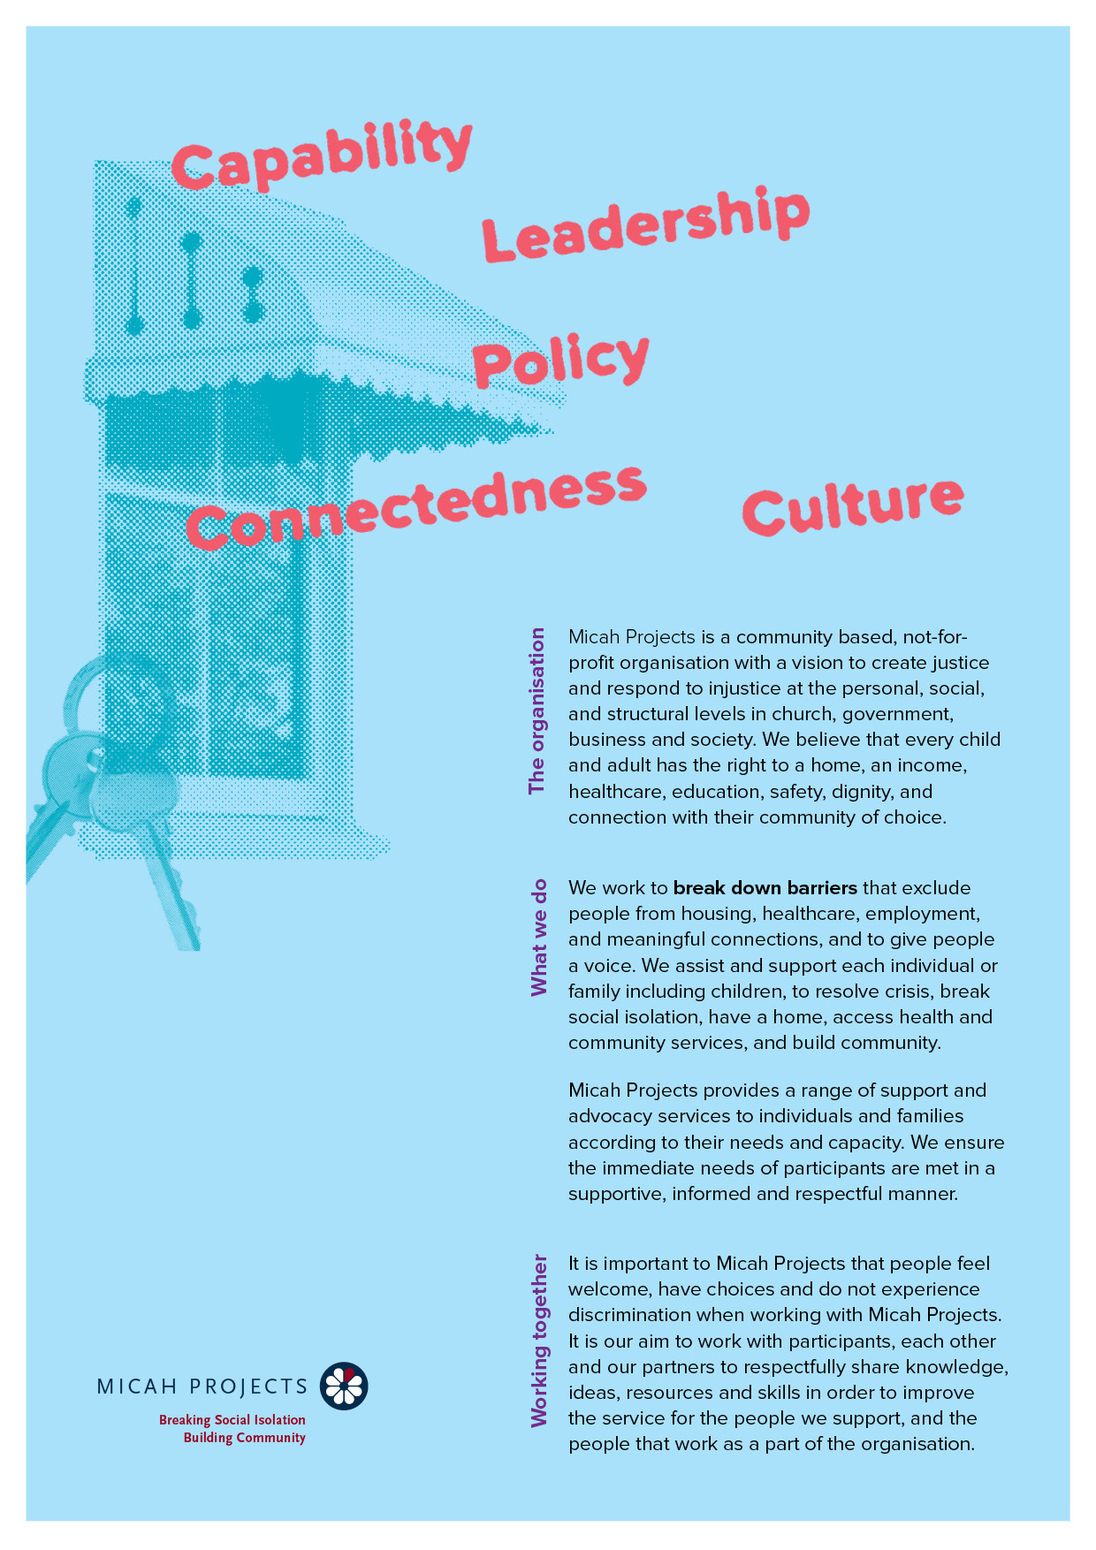
Women, Children & Families
Early Years Program
Kitchen/Cook/Food Handling Support
Volunteer

Equal Opportunity  Micah Projects is an equal opportunity employer and promotes access to positions to individuals from a diverse range of social and cultural groups. We acknowledge the First Peoples of Australia as the traditional owners of this land and support their right to self-determination and cultural expression. We recognise that Brisbane is a diverse community and acknowledge the needs of individuals, families and communities relating to age, gender, disability, sexuality and economic status. | Child Safe Organisation  Children and young people are entitled to live in a caring and nurturing environment and to be protected from harm and exploitation. Micah Projects is a child-safe and child-friendly organisation that prioritises the safety and wellbeing of children and young people. We actively provide guidance for management, staff and others in identifying and responding to concerns about the abuse or neglect of a child or young person in contact with the organisation.
Quality statements  Micah Projects is committed to adhering to well defined, effective procedures that are designed to ensure the quality of our services and activities. We expect staff to understand the relevance and importance of their activities and how they contribute to achieving the quality objectives, and to proactively work and operate within the organisation’s quality system. | WHS Statement  Everyone has a right to feel safe at work, and Micah Projects is committed to minimising the risk to any staff member, student, volunteer, contractor, consultant and Board member within the organisation. We work collectively to comply with the Work Health and Safety Act 2015.


Position Overview

Position Title | Team
  Kitchen/Cook Volunteer
  Women, Children & Families
Reports to | Line Manages
  Claire Middleton
  Nil
Employment Status | Hours of Work
  Volunteer
  Friday every week
  9am – 1pm
Based at
Hawthorne Families Hub

Micah Projects – CLUSTER - Women, Children & Families

The Women, Children & Families Cluster is made up of a number teams within Micah Projects that support women & children. Teams include The Wellspring Children and Families Hub including the Early Years Program, a therapeutic early care and education program for children aged 0-5. The Healthy & Safe Start Team supports pregnant women or women with children under 5 years who are experiencing homelessness and / or DFV. Children, Young People Team support children and young people and their safe caregiver, who have been exposed to DFV, offering group work and counselling to assist in recovery.

Position Description

As a Group Work volunteer, you will….
Assist Micah Project staff to support children who attend our Early Years Program.

Wednesday, Thursday & Friday:
Wellspring Early Years Program: 9am – 1pm:
Prepare and cook lunches and afternoon teas for children attending the Wellspring Early Years Program.
Follow food handling guidelines and support the maintenance of a food safe kitchen.
Responsibilities  - Follow a menu to prepare and cook a hot lunch meal for up to 16 children.  - Prepare and store afternoon tea for up to 16 children.  - Work with Micah staff to clean up after meals and maintain a clean, hygienic kitchen.  - Work with Micah staff to support the management of food for children with special dietary requirements.  - Monitor and record fridge temperature and food temperature checks.  - Advise Micah staff when pantry supplies and ingredients are running low.  - Participate in food safe and other relevant training. | Interactions and Relationships
  - Participants
  - Micah Staff

Criteria and Conditions

Driver’s License: Preferred but Not Essential | Travel: Ability to get to Hawthorne
Criminal History Screening: Blue Card | Assets: N/A

Essential
» Ability to work as a part of a team.
» A friendly personality and good interpersonal and communication skills.
» Work with limited supervision and be able to take direction when required.
» Be energetic, enthusiastic, and reliable.
» A referee who is not a relative and can verify your character and interaction in the community.

General Conditions
» All volunteers are to exhibit the values of Micah Projects, as outlined in the Code of Conduct.
» All volunteers must utilise Micah Projects systems to facilitate the quality of the organisation’s work and services.
» Appointment to this position will be subject to a criminal history check, as outlined in the organisational Criminal History Screening Policy.
» All volunteers will comply with Workplace Health and Safety legislation as outlined in organisational policy and procedures.

Volunteer Expression of Interest

