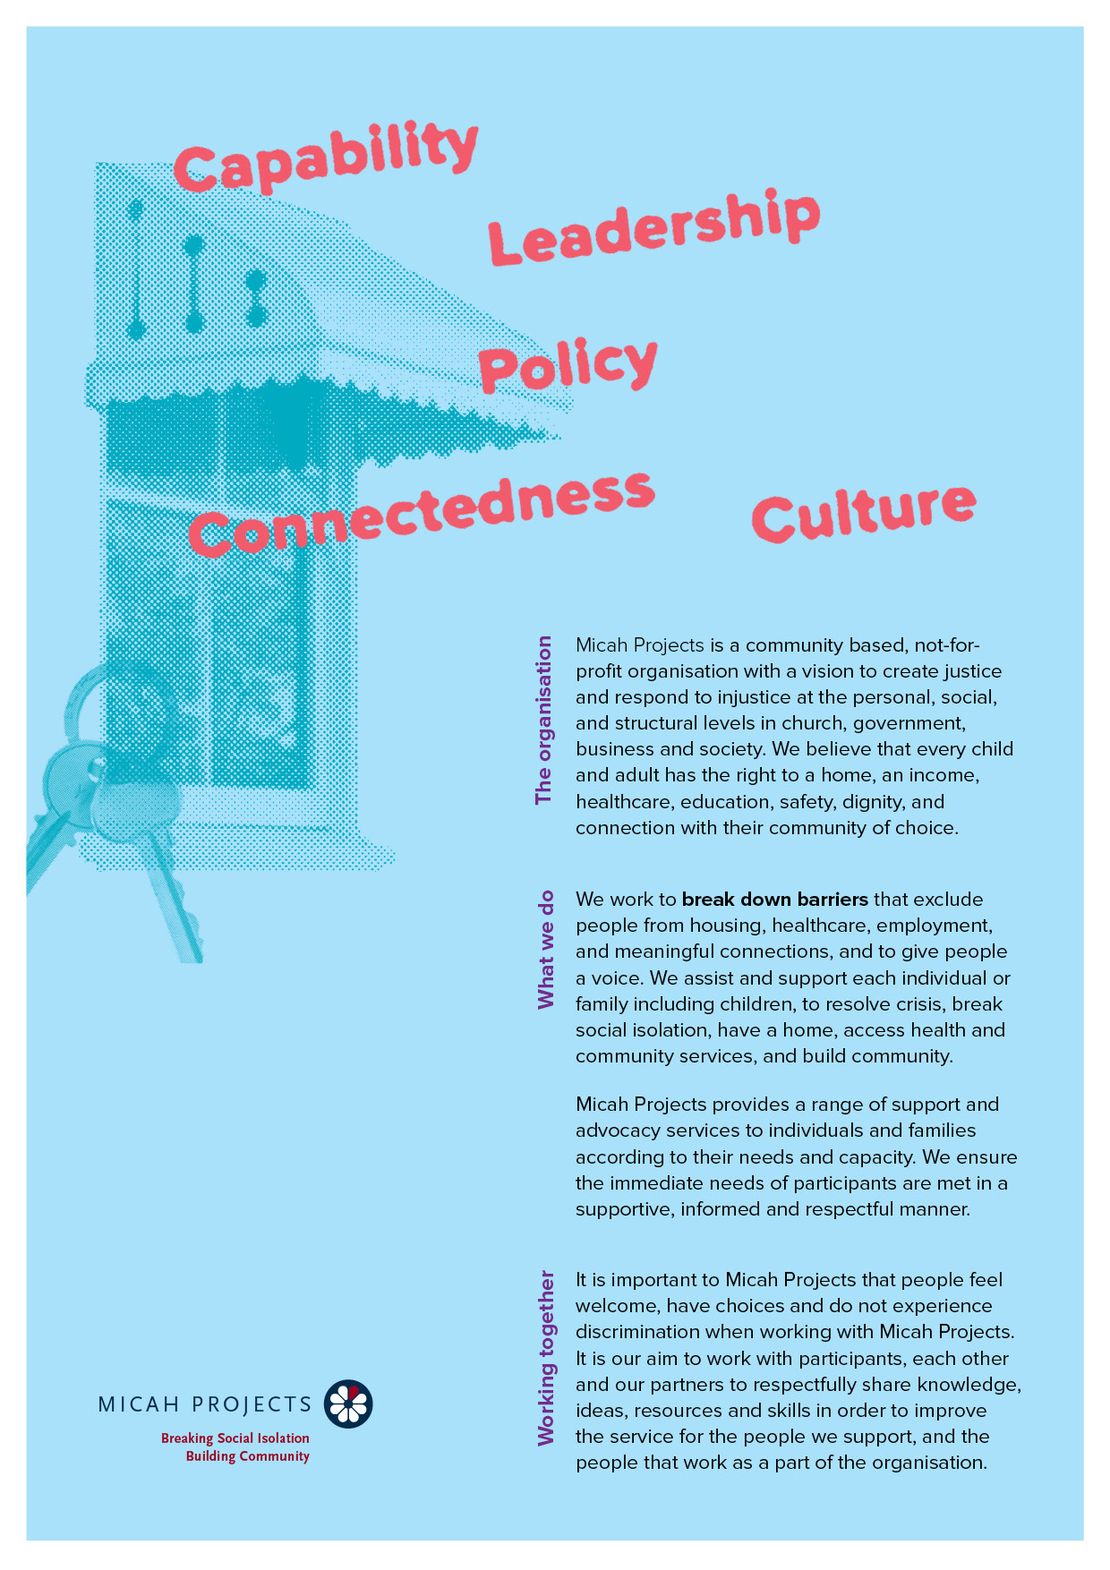
Art Therapist
Volunteer

Equal Opportunity  Micah Projects is an equal opportunity employer and promotes access to positions to individuals from a diverse range of social and cultural groups. We acknowledge the First Peoples of Australia as the traditional owners of this land and support their right to self-determination and cultural expression. We recognise that Brisbane is a diverse community and acknowledge the needs of individuals, families and communities relating to age, gender, disability, sexuality and economic status. | Child Safe Organisation  Children and young people are entitled to live in a caring and nurturing environment and to be protected from harm and exploitation. Micah Projects is a child-safe and child-friendly organisation that prioritises the safety and wellbeing of children and young people. We actively provide guidance for management, staff and others in identifying and responding to concerns about the abuse or neglect of a child or young person in contact with the organisation.
Quality statements  Micah Projects is committed to adhering to well defined, effective procedures that are designed to ensure the quality of our services and activities. We expect staff to understand the relevance and importance of their activities and how they contribute to achieving the quality objectives, and to proactively work and operate within the organisation’s quality system. | WHS Statement  Everyone has a right to feel safe at work, and Micah Projects is committed to minimising the risk to any staff member, student, volunteer, contractor, consultant and Board member within the organisation. We work collectively to comply with the Work Health and Safety Act 2015.


Position Overview

Position Title | Team
  Volunteer – Art Therapist
  Wellspring Women and Girls’ Health Hub
Reports to | Line Manages
  Cluster Lead
  NA
Employment Status | Hours of Work
  Volunteer
  Monday or Thursday
  3-4 hours per week
  After 9.30am
Based at
Caboolture

Micah Projects – Wellspring Moreton Bay - Wellspring Women and Girls’ Health Hub

The Women and Girls’ Health Hub is funded by Queensland Health to offer services to all women and girls with a focus on priority communities of women and girls who experience worse long-term health outcomes than the general population, due to significant barriers that impact these communities such as lack of culturally safe and appropriate health care. The Hub offers a mix of medical, nursing, counselling, and social services. True Relationships and Reproductive Health and Women’s Health and Equality Queensland also provide services from the Hub.

Position Description

As an Art Therapist Volunteer, you will….

The Volunteer Art Therapist will provide trauma-informed, strengths-based art therapy support to women accessing Wellspring Women and Girls’ Health Hub. The role supports women’s emotional wellbeing, recovery, connection, and self-expression through creative approaches, within a safe, culturally responsive, and inclusive environment.

This role complements the hub’s multidisciplinary model, working alongside health, counselling, social support, and community services to improve wellbeing outcomes for women, particularly those experiencing vulnerability, trauma, family and domestic violence, homelessness, or social isolation.
Responsibilities  - Provide group-based art therapy sessions for women accessing the hub  - Use evidence-informed, trauma-aware art therapy approaches tailored to women’s needs  - Create emotionally and physically safe therapeutic spaces that support choice, agency, and empowerment  - Support women to explore emotions, experiences, and strengths through creative expression  - Maintain clear boundaries within a volunteer scope of practice  - Participate in care discussions and service coordination meetings as appropriate  - Apply a gendered, trauma-informed lens to all interactions | Interactions and Relationships
  - Participants
  - Other Hub team members and external partner organisations
  - Volunteer Coordinator

Criteria and Conditions

Driver’s License: Preferred but Not Essential | Travel: Optional
Criminal History Screening: Blue Card | Assets: N/A

Essential
» Qualification in Art Therapy (minimum Bachelor level) or eligibility for professional membership
» Experience working with women and/or trauma-affected populations
» Understanding of trauma-informed, strengths-based practice frameworks
» Ability to work collaboratively within a multidisciplinary team
» Strong interpersonal and communication skills
» Commitment to ethical practice, confidentiality, and professional boundaries
» Ability to work as a part of a team.
» A friendly personality and good interpersonal and communication skills.
» Work with limited supervision and be able to take direction when required.
» Be energetic, enthusiastic, and reliable.
» A referee who is not a relative and can verify your character and interaction in the community.

General Conditions
» All volunteers are to exhibit the values of Micah Projects, as outlined in the Code of Conduct.
» All volunteers must utilise Micah Projects systems to facilitate the quality of the organisation’s work and services.
» Appointment to this position will be subject to a criminal history check, as outlined in the organisational Criminal History Screening Policy.
» All volunteers will comply with Workplace Health and Safety legislation as outlined in organisational policy and procedures.

Volunteer Expression of Interest

