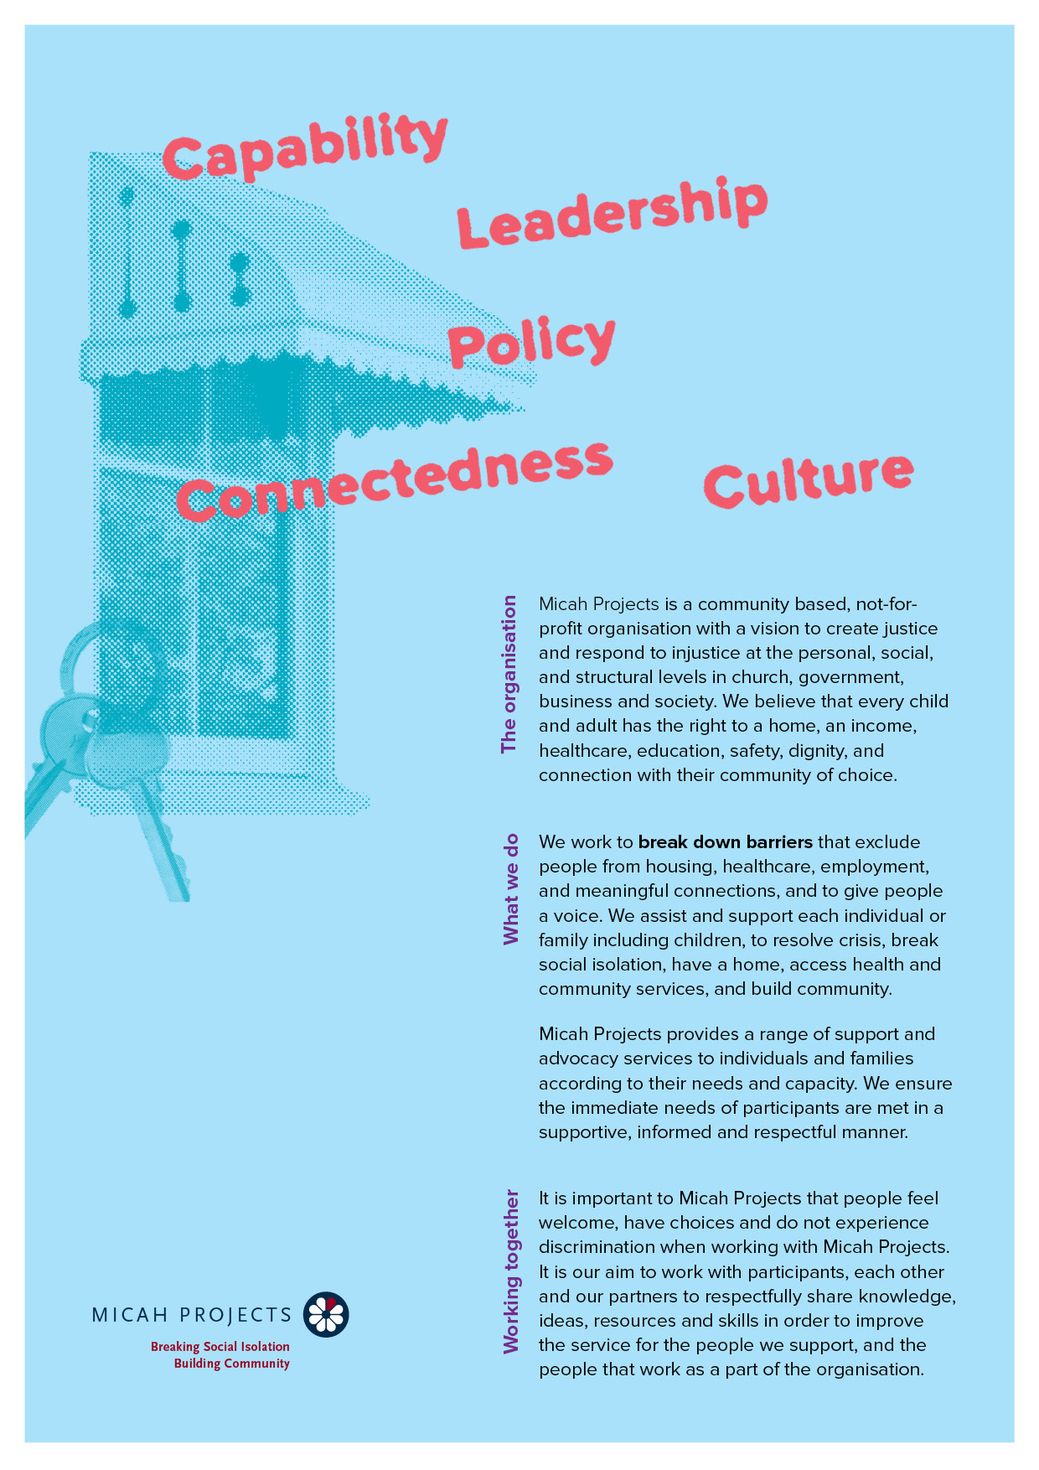
Student Work Experience Opportunity:
Café All-Rounder Volunteer

Equal Opportunity  Micah Projects is an equal opportunity employer and promotes access to positions to individuals from a diverse range of social and cultural groups. We acknowledge the First Peoples of Australia as the traditional owners of this land and support their right to self-determination and cultural expression. We recognise that Brisbane is a diverse community and acknowledge the needs of individuals, families and communities relating to age, gender, disability, sexuality and economic status. | Child Safe Organisation  Children and young people are entitled to live in a caring and nurturing environment and to be protected from harm and exploitation. Micah Projects is a child-safe and child-friendly organisation that prioritises the safety and wellbeing of children and young people. We actively provide guidance for management, staff and others in identifying and responding to concerns about the abuse or neglect of a child or young person in contact with the organisation.
Quality statements  Micah Projects is committed to adhering to well defined, effective procedures that are designed to ensure the quality of our services and activities. We expect staff to understand the relevance and importance of their activities and how they contribute to achieving the quality objectives, and to proactively work and operate within the organisation’s quality system. | WHS Statement  Everyone has a right to feel safe at work, and Micah Projects is committed to minimising the risk to any staff member, student, volunteer, contractor, consultant and Board member within the organisation. We work collectively to comply with the Work Health and Safety Act 2015.


Position Overview

Position Title | Team
  Volunteer: Café All-Rounder
  Community Connections
Reports to | Line Manages
  Community Inclusion and Café Manager
  N/A
Employment Status | Hours of Work
  Volunteer
  Fridays 0830 – 1030AM
  Saturday 0830 – 1030AM OR 1230-1430
  Sunday 0930 – 12noon
Based at
South Brisbane 4101

Micah Projects – Community Connections - Social Enterprise: Hope Street Café and Catering

Hope Street Cafes are social enterprises that serve as community-focused cafes with a mission to create positive social impact. We operate in alignment with the principles of social responsibility and sustainability. Our aim is to blend business with social good by using the proceeds from our operations to support local communities, foster inclusivity, and contribute to meaningful social change, along with providing training and employment for those that have significant barriers to employment.

Position Description

As a Café All-Rounder volunteer you will be part of Micah Projects Community Connections team. In this role you will work together with Micah staff to support the production and service of healthy meals and beverages for participants of Micah Projects.

We are seeking enthusiastic and dedicated volunteers to join our team as Cafe All-Rounders. As a volunteer, you will play a crucial role in supporting our social enterprise cafe while gaining valuable hands-on experience in a dynamic and socially responsible environment.
Responsibilities  - Assist with the daily operations of the cafe, including but not limited to, taking orders, preparing and serving beverages and food, and maintaining a clean and organized workspace.  - Provide excellent customer service by engaging with cafe patrons, answering questions, and ensuring a welcoming and inclusive atmosphere.  - Collaborate with the cafe team to help with inventory management, restocking supplies, and ensuring efficient workflows.  - Contribute to the promotion of our social enterprise's mission and values to cafe visitors.  - Assist in organizing and participating in special events, workshops, or fundraisers hosted at the cafe.  - Follow health and safety guidelines to maintain a safe and hygienic cafe environment. | Interactions and Relationships
  - Participants
  - Community Inclusion Team Members
  - Micah Employees
  - Volunteer Coordinator
  - Members of the Community

Criteria and Conditions

Driver’s License: Preferred but Not Essential | Travel: Optional
Criminal History Screening: Blue Card | Assets: N/A

Essential
- Passion for social enterprise, sustainability, hospitality and community engagement.
- Excellent communication and interpersonal skills.
- Ability to work as part of a team and take initiative when needed.
- Basic knowledge and experience of barista skills, service, food handling and preparation.
- Commitment and reliability to volunteer for a specified number of hours per week as per the agreed upon schedule.

General Conditions
- All volunteers are to exhibit the values of Micah Projects, as outlined in the Code of Conduct.
- Appointment to this position will be subject to a valid Blue Card or ability to acquire one, as outlined in the organisational Criminal History Screening Policy.
- All volunteers need to have a valid Blue Card prior starting their volunteering.
- All volunteers will comply with Workplace Health and Safety legislation as outlined in organisational policy and procedures.

Benefits:
- Gain practical experience in a cafe setting with a socially responsible focus.
- Develop customer service, teamwork, and problem-solving skills.
- Contribute to a meaningful cause and support the local community.
- Networking opportunities within the social enterprise and hospitality sector.
- Training and mentorship from experienced cafe staff and hospitality professionals.
Volunteer Expression of Interest

