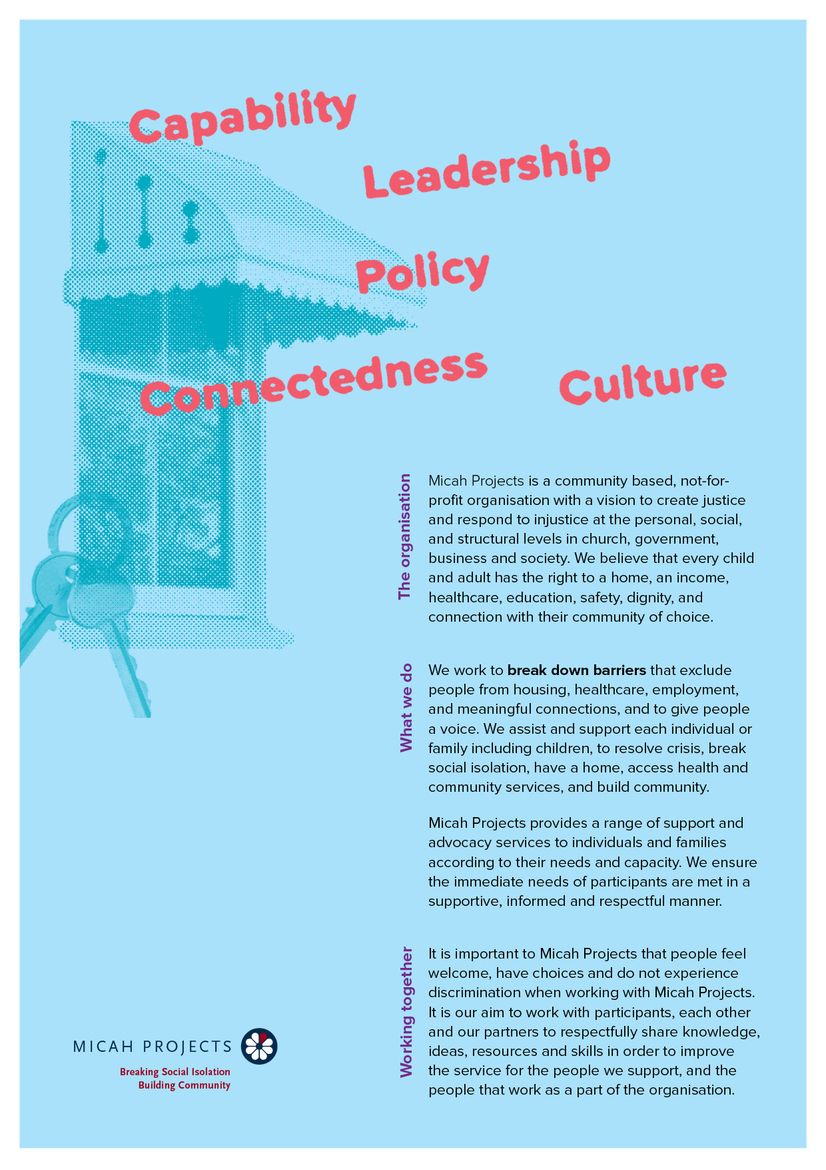
Supportive Housing – Hope Street

Volunteer

Equal Opportunity  Micah Projects is an equal opportunity employer and promotes access to positions to individuals from a diverse range of social and cultural groups. We acknowledge the First Peoples of Australia as the traditional owners of this land and support their right to self-determination and cultural expression. We recognise that Brisbane is a diverse community and acknowledge the needs of individuals, families and communities relating to age, gender, disability, sexuality and economic status. | Child Safe Organisation  Children and young people are entitled to live in a caring and nurturing environment and to be protected from harm and exploitation. Micah Projects is a child-safe and child-friendly organisation that prioritises the safety and wellbeing of children and young people. We actively provide guidance for management, staff and others in identifying and responding to concerns about the abuse or neglect of a child or young person in contact with the organisation.
Quality statements  Micah Projects is committed to adhering to well defined, effective procedures that are designed to ensure the quality of our services and activities. We expect staff to understand the relevance and importance of their activities and how they contribute to achieving the quality objectives, and to proactively work and operate within the organisation’s quality system. | WHS Statement  Everyone has a right to feel safe at work, and Micah Projects is committed to minimising the risk to any staff member, student, volunteer, contractor, consultant and Board member within the organisation. We work collectively to comply with the Work Health and Safety Act 2015.


Position Overview

Position Title | Team
  Volunteer Art Assistant / Studio Support
  Supportive Housing – Hope Street
Reports to | Line Manages
  Art Facilitator - Katie McGuire
  Andy Johnson
Employment Status | Hours of Work
  Volunteer
  Wednesdays 10am -12.30pm
Based at
Brisbane Common Ground, South Brisbane

Micah Projects – Supportive Housing -Hope Street
Micah Projects – Supportive Housing: Hope Street
As the appointed support provider at Brisbane Common Ground (BCG) supportive housing initiative combining permanent, affordable housing with on-site support to help people sustain their tenancy and live with dignity and purpose. Also providing a range of programs that strengthen social inclusion and community connection. This includes the Brisbane Common Ground Art Program, which offers weekly art and craft sessions in the on-site Art Studio exclusively for tenants, fostering creativity, confidence, and community wellbeing. Often Artists/tenants attending these groups have a lived experience of social isolation and exclusion as a result of the stigmas and social barriers associated with homelessness, mental health, disability and poverty.

Position Description

Position Description: Volunteer Art Assistant / Studio Support
About the Role
We are seeking a Volunteer Art Assistant to support the delivery of weekly Art and Craft Studio sessions for tenants at Brisbane Common Ground.
Two sessions are held each Wednesday morning and afternoon, offering participants a safe and creative space to explore artmaking, connection, and self-expression.
In this role, you’ll assist the Art Facilitator with preparing materials, welcoming participants, supporting creative activities, and helping maintain a relaxed, inclusive atmosphere. You’ll contribute to both Craft Group and Art Studio Group sessions, working alongside tenants as they create artworks in a variety of mediums: drawing, painting, and collage, to sculpture, fabric art, and small-scale crafts.
This is a rewarding volunteer opportunity for someone who values creativity, community connection, and inclusion, and who enjoys helping others express themselves through art.

Key Responsibilities
- Assist in the preparation, delivery, and pack-down of weekly art and craft sessions.
- Support participants to engage in creative activities at their own pace and comfort level.
- Help demonstrate or assist with simple art or craft techniques as guided by the facilitator.
- Encourage creative confidence, curiosity, and a sense of achievement among participants.
- Assist in maintaining an organised, safe, and welcoming studio environment.
- Support the facilitator with basic materials tracking, tidying, and set-up for future sessions.
- Contribute to a calm, inclusive, and non-judgmental group culture that promotes wellbeing and respect.

Essential Skills & Attributes
- Ability to work as a part of a team.
- A friendly personality and good interpersonal and communication skills.
- Work with limited supervision and be able to take direction when required.
- Be energetic, enthusiastic, and reliable.
- A genuine interest in art, craft, and creative expression.
- Friendly, respectful, and patient approach when engaging with others.
- Comfortable engaging with people from diverse backgrounds and life experiences.
- Respect for boundaries, confidentiality, and Micah Projects’ values of inclusion and dignity.
- Ability to provide a character referee (non-relative) who can speak to your reliability and community involvement.

Desirable Skills
- Experience in one or more art or craft mediums (e.g. drawing, painting, collage, ceramics, beading, textiles, etc.).
- Experience supporting others in community, group, or wellbeing settings.
- Basic organisational or administrative skills (recording materials used, assisting setup lists).
- Awareness of trauma-informed or mental health support principles (training can be provided).

What You’ll Gain
- The opportunity to contribute to a creative, community-focused program that enhances wellbeing.
- Hands-on experience supporting a community arts initiative within a supportive housing context.
- Mentorship and guidance from experienced arts and community practitioners.
- A chance to share your creative enthusiasm and develop facilitation skills.
- A professional reference to support future employment, study, or creative opportunities.
- Connection with a warm, inclusive, and purpose-driven organisation.

Driver’s License: n/a | Travel: n/a
Criminal History Screening: Blue Card | Assets: n/a

Essential
» Ability to work as a part of a team.
» A friendly personality and good interpersonal and communication skills.
» Work with limited supervision and be able to take direction when required.
» Be energetic, enthusiastic, and reliable.
» A referee who is not a relative and can verify your character and interaction in the community.

General Conditions
» All volunteers are to exhibit the values of Micah Projects, as outlined in the Code of Conduct.
» All volunteers must utilise Micah Projects systems to facilitate the quality of the organisation’s work and services.
» Appointment to this position will be subject to a criminal history check, as outlined in the
» All volunteers will comply with Workplace Health and Safety legislation as outlined in organisational policy and procedures.

How to Apply
- If you're interested in becoming a Craft Champion at BCG and helping others discover the joy of creativity, we’d love to hear from you!

