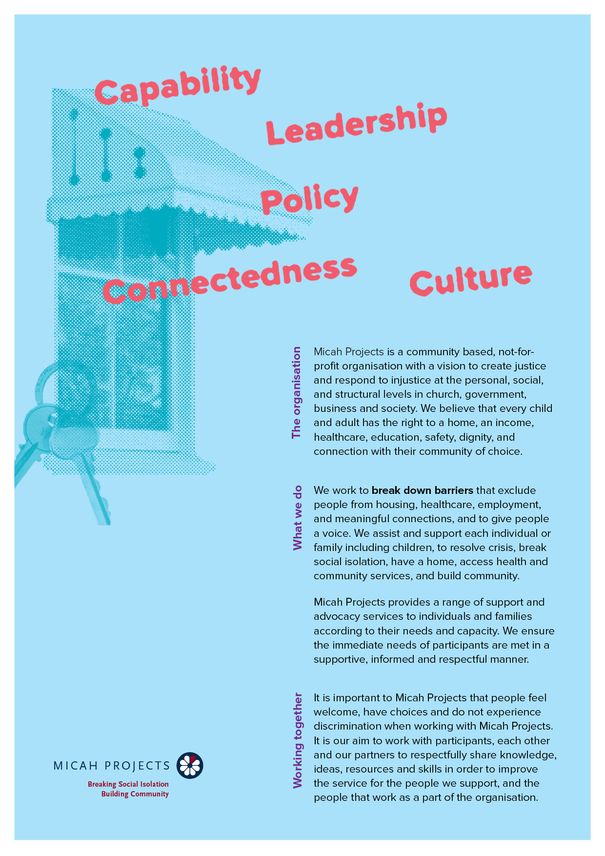
Organisation
Pantry Support
Volunteer

Equal Opportunity  Micah Projects is an equal opportunity employer and promotes access to positions to individuals from a diverse range of social and cultural groups. We acknowledge the First Peoples of Australia as the traditional owners of this land and support their right to self-determination and cultural expression. We recognise that Brisbane is a diverse community and acknowledge the needs of individuals, families and communities relating to age, gender, disability, sexuality and economic status. | Child Safe Organisation  Children and young people are entitled to live in a caring and nurturing environment and to be protected from harm and exploitation. Micah Projects is a child-safe and child-friendly organisation that prioritises the safety and wellbeing of children and young people. We actively provide guidance for management, staff and others in identifying and responding to concerns about the abuse or neglect of a child or young person in contact with the organisation.
Quality statements  Micah Projects is committed to adhering to well defined, effective procedures that are designed to ensure the quality of our services and activities. We expect staff to understand the relevance and importance of their activities and how they contribute to achieving the quality objectives, and to proactively work and operate within the organisation’s quality system. | WHS Statement  Everyone has a right to feel safe at work, and Micah Projects is committed to minimising the risk to any staff member, student, volunteer, contractor, consultant and Board member within the organisation. We work collectively to comply with the Work Health and Safety Act 2015.


Position Overview

Position Title | Team
  Pantry Volunteer
  Organisational Services
Reports to | Line Manages
  Office Administrator
  n/a
Employment Status | Hours of Work
  Volunteer
  Every Wednesday
  10am – 11am (1 hour)
Based at
West End Q 4101

Micah Projects – Organisational Services - Team

Position Description

As an Pantry Volunteer, you will….

Assist Micah Projects staff to pack and maintain enough food parcels in the pantry to meet the needs of our participants..
Responsibilities  - Assist Micah staff to assist participants who require a food parcel from the Micah Projects pantry.  - Each week , we require the assistance to pack food hampers , accept deliveries from the supermarket and then store food not used into storage cupboards. | Interactions and Relationships
  - Participants
  - Social Inclusion Workers
  - Volunteer Coordinator
  - Members of the Community

Criteria and Conditions

Driver’s License: Preferred but Not Essential | Travel: Optional
Criminal History Screening: Blue Card | Assets: N/A

Essential
» Ability to work as a part of a team.
» A friendly personality and good interpersonal and communication skills.
» Work with limited supervision and be able to take direction when required.
» Be energetic, enthusiastic, and reliable.
» A referee who is not a relative and can verify your character and interaction in the community.

General Conditions
» All volunteers are to exhibit the values of Micah Projects, as outlined in the Code of Conduct.
» All volunteers must utilise Micah Projects systems to facilitate the quality of the organisation’s work and services.
» Appointment to this position will be subject to a criminal history check, as outlined in the organisational Criminal History Screening Policy.
» All volunteers will comply with Workplace Health and Safety legislation as outlined in organisational policy and procedures.

Volunteer Expression of Interest

